The Aligned Female Entrepreneur with Krissy Leonard

WEEk 1 WORKBOOK

Week 1 Core Teachings
- Everything starts with your VISION. Your desires are sacred. This is the path to your purpose. From your vision you set your GOALS, then take ALIGNED ACTION to achieve them.
- Three Keys for getting the most out of this group: 1. cultivate TRUST/confidentiality 2. look for the POSITIVE 3.cultivate SOLUTION-BASED thinking.
- Key to success is to focus less on yourself, and more on how you can serve others.
- THREE STEPS TO GET ANYTHING YOU WANT: 1. get clear on what you want (vision and goals) 2. Identify any limiting beliefs getting in your way 3. Take consistent, aligned ACTION.
- Without action, nothing changes. INSIGHT WITHOUT ACTION IS USELESS.
- EXPECT resistance. It is totally normal and natural - learn to identify your unique flavor and work with it. AKA feel the resistance and do it anyways!
- It’s okay for things to be messy and imperfect along the way. Start anyways. CLARITY COMES THROUGH ACTION.
- Where your Global Vision Statement, your Personal Power Statement, and your Ideal Client’s deepest desires merge is your SWEET SPOT. When you do work from this place, you create more energy, alignment, income and impact.

DISCOVERING YOUR “SWEET SPOT”
WHY THIS MATTERS
Your “Sweet Spot” is where you have the highest chance for success in creating a profitable soul-centered business because when you combine your Global Vision Statement (what you want for the world), with your Personal Power Statement (your unique talents, gifts, and skills), and your Ideal Clients Desires (the people who love what you offer, need what you have to give, or want to buy what you’re selling) you get to make a great income doing work you love AND making a meaningful contribution to the world.
STEP 1: CREATE YOUR GLOBAL VISION STATEMENT
Your Global Vision Statement is your “why” for the world. Starting with WHY is so critical in any business or endeavor. You why is the deeper reason you do what you do. It’s your vision of the change you want to see. It’s that thing that calls you to serve or contribute in a bigger way.
Questions to uncover your “why” and Global Vision Statement:
What do you Value?

What do you want to take a stand for?

What breaks your heart in this world?

What are you passionate about?
If there was a message or “truth” that you feel so strongly about that you could shout it from the rooftops, what would it be?

What is the change you want to see in the world?

STEP 2: DRAFT YOUR GLOBAL VISION STATEMENT
I find that the best Vision statements are to the point, and begin with phrases such as “my vision for the world is…” or “I want to Iive in a world where…” or “I want to contribute to a world where…”;
Example 1: My vision for the world is for every women to know her worth. To be able to have the financial means and capacity necessary to do work she loves while making a positive impact on her community and in the world. I see a world where women lift each other up instead of tearing each other down…where no women rests until we are all free.
Example 2: My vision is to have everyone on the planet feel great in their body and their physical appearance so that they can move forward with confidence and ease and live a deeply fulfilling life.
Draft your vision statement below:

STEP 3: UNCOVER YOUR PERSONAL POWER STATEMENT
This is where we clarify YOUR gifts. This can be a little tricky because you often don’t see these things as gifts because they are just so natural to you you cant imagine going through life without them! But chances are you have a good idea what some of the big ones are.
Questions to uncover your gifts to craft your Personal Power Statement:
What are you naturally good at?

What do you love to do in your work?

Outside of work?

What are your strengths or skills that you’ve developed over time?

What life-changing experiences have you had?

What struggles have you had to overcome?

What was the hard-earned lesson or insight you received from those challenges?

What are your top 5 past successes at work? What is the common theme?

What would I want to overhear about me at a party?

What contributions would I like to make to the world?

What are you scared to impart/teach/offer, but know that it’s time for it anyway?

HOW do you want to help?
STEP 4: DRAFT YOUR PERSONAL POWER STATEMENT
Your personal power statement articulates HOW you contribute to your Global Vision through using YOUR unique gifts. Keep it short - 1-5 sentences.
Example: I combine my unique skills of visioning, creativity, intuition and connection with my superpowers of strategic thinking, business and marketing savvy, and ability to break things down step-by-step to help women create more freedom in their body and business so they can free up their energy to create a meaningful impact in the world.
Draft your Personal Power Statement Below:

Now write down 2 words that really encapsulate the essence of your personal power statement. __________________________ and ____________________________.

Notice how your Vision and Power Statement feel on a scale of 1-5. If they are less than a 5, tweak it until it lights you up. Stretch yourself here.

STEP 5: IDENTIFY YOUR TARGET CLIENT
Now that you know why you are here, and how you can uniquely contribute to your global vision with your unique skills, we want to identify your target client or target market.
Questions to identify your target client:
What type of person, or group would benefit most by your unique skills and abilities?

Who needs what you have?

Who would LOVE to receive the gifts you outlined above? Who needs the medicine you have to offer?

What gets this person or group excited?

What are their interests?

What is most important to them?

What are they scared of?

Where are they feeling stuck/what is the problem they are facing?

What are they afraid might happen if they don’t get their problem solved?

What do they HOPE is possible for them?

What age are they? What other common characteristics do they have?

STEP 5: UNCOVER YOUR SWEET SPOT
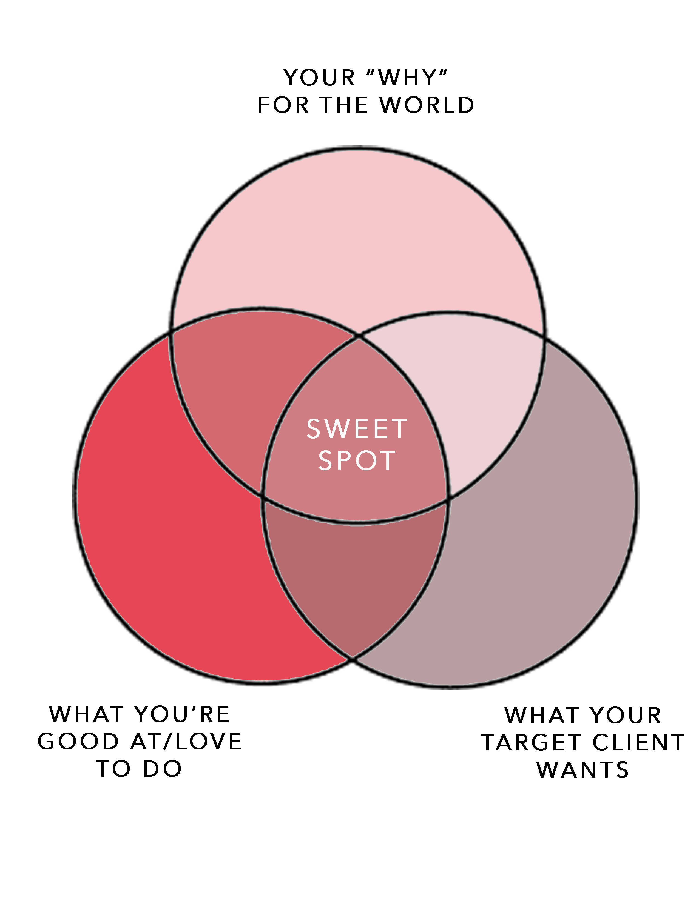
Nice work! Now do some brainstorming, journaling and noticing about how these might all come together. Where your vision for the world, your unique gifts / what you love to do, and what people want to purchase meet is the golden opportunity for creating a profitable, soul-centered business.
It’s okay for this to feel messy and unclear at first. Keep going. I am also giving you some homework that will help refine this and paint the picture for you. Trust it will become clear and absolutely perfect.

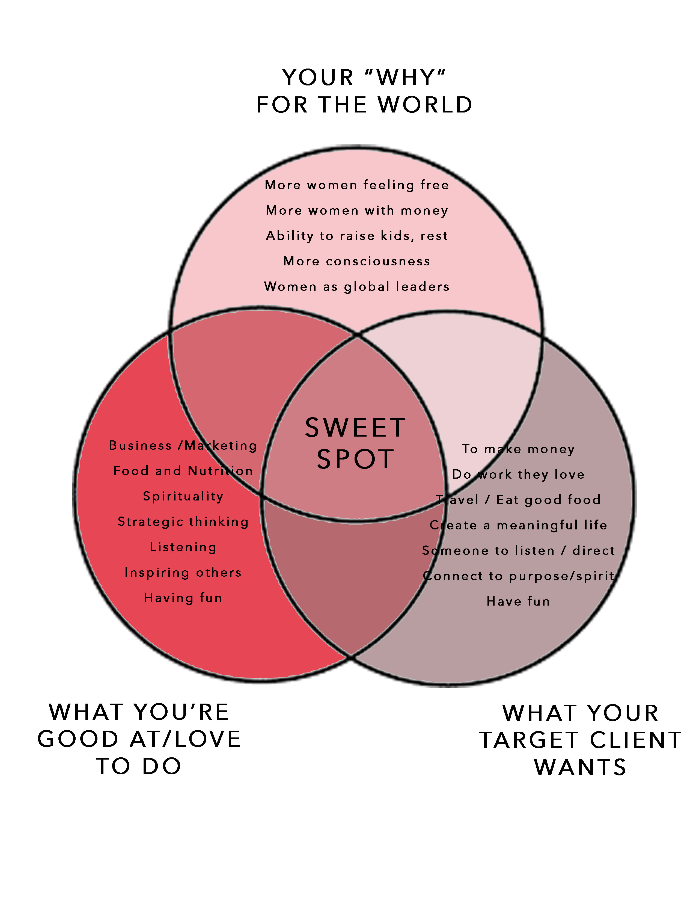
Example from my business:
My sweet spot: Helping women create soul-centered businesses that make them money from anywhere in the world, while making a difference, having fun, and eating well in the process.
NOW IT’S YOUR TURN…PLAY BELOW!
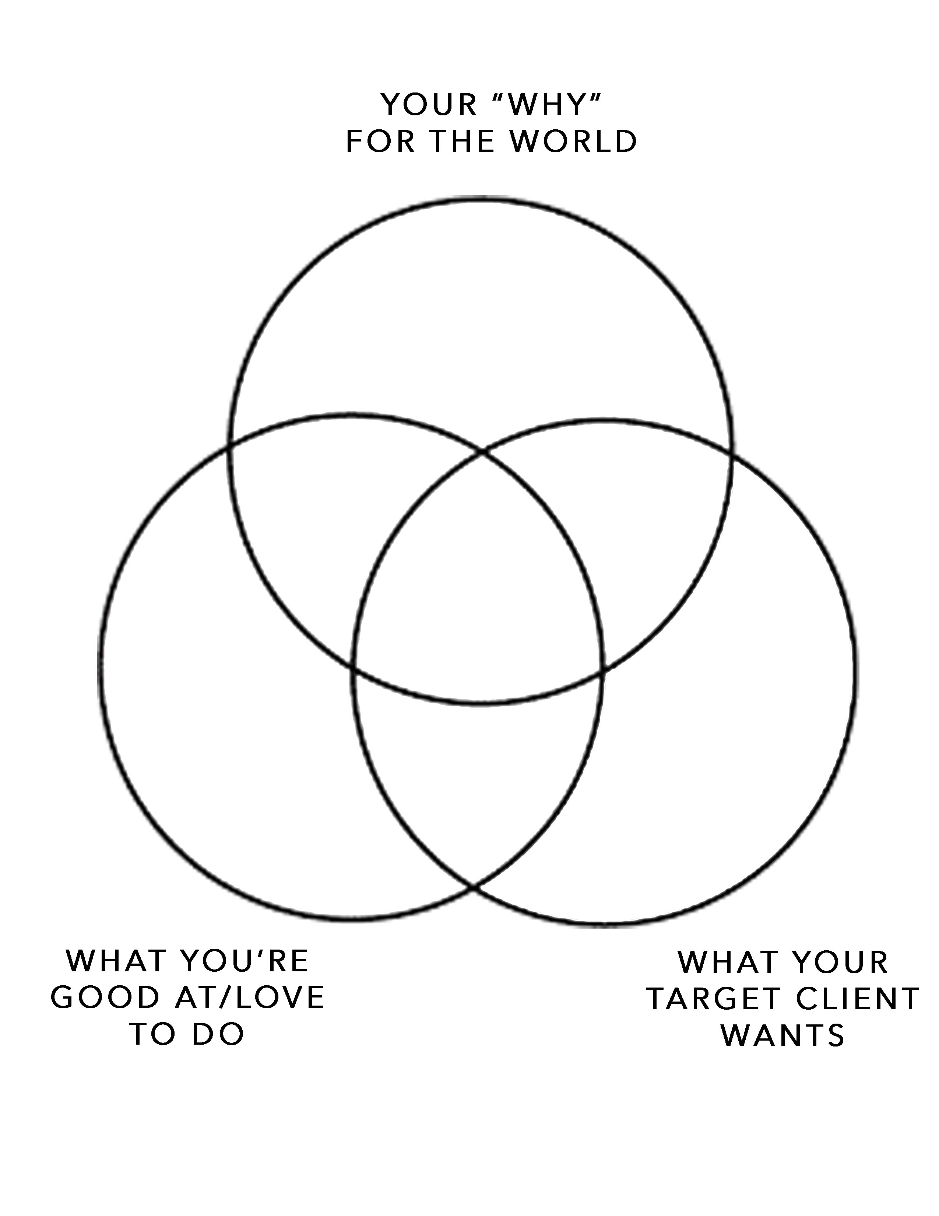

WEEK 1 HOMEWORK:
- Answer journal prompts
- Draft your Vision for the World, your Personal Power Statement, and your Ideal Client.
- Reach out to 5-10 past colleagues, friends or family members – people who know you well and ask: “what are my top 3-5 strengths? What am I doing when you see me at my best?” Incorporate these insight into your “gifts.” This is SUPER fun and SO insightful!
- Talk to 1-3 people who could be your ideal client and learn more about what they want, what they struggle with and what would be their dream solution (question prompts on next page).
- Notice what comes through, and come up with a “what you do” statement for your sweet spot (see example provided). This doesn’t need to be perfect, you just need a start!

QUESTIONS FOR POTENTIAL CLIENTS:
Daily, heart-felt conversations are a great way to gather information from potential clients when starting in business or creating a new product.

You can even ask a friend or colleague who you think you might be an ideal client to lunch and ask them these questions face to face. Let it be organic rather than super structured so that they are able to feel safe and open up.

Be sure to write down their EXACT words instead of what you “think” you’re hearing.

For instance instead of writing down “lose weight,” capture the EXACT words. Ex: “I’d like to lose 20 pounds, but I also love food and wine haha! I just wish food was no longer ‘an issue’ you know what I mean? And sure, it would be nice if my jeans fit again, too!”

We’ll use these insights to craft compelling copy (wording on your website, and marketing materials) the speaks DIRECTLY to your ideal client.

- What are your three biggest frustrations surrounding ______ (current problem/area you could help them in)?

- What have you tried before to help solve this problem? What was your experience like

- If you were able to have this problem solved, what would having that do for you?

- What would be the best part?

- What has been your biggest frustration when it comes to getting this problem solved?

- What holds you back?

- How important is this for you to handle right now?

- Have you ever paid for a product/service like this before? If so, what did you pay?

- What did you like best about it? What frustrated you about buying this kind of product or service?

- What’s a dream solution for you in this area?

